Portfolio Status Reporting – Automation with PowerPoint

**Applies To**: PowerPoint 2007 and above, MS SharePoint

***Create automated PowerPoint reporting for portfolio of projects for publishing to project portals, email to stakeholder, on demand and in various formats.***

## 

## **Overview**

## **Introduction**

Though this is not strictly a continuation of the previous article I [posted](https://www.projectmanagement.com/articles/360700/Creating-PMO-Dashboards-for-Reporting-Projects--Portfolios-and-Programs), I have used the two in tandem to optimize my reporting and communication workload.

This write-up will show some simple and effective automation I have been using to publish and communicate one pager (or dashboard) project status reports using MS PowerPoint.

Along the way, I will explain how this is one of the many use cases possible, and point to other possibilities to adapt to your needs.

## **Target Audience:**

Project/portfolio/program managers working on multiple projects or programs having basic VBA skills (or able to delegate the programming or customizing the use case cited here).

## **Purpose**

This approach, involving some VBA programming, can reduce repetitive and periodic task of reporting and uploading status reports.

I have been using something similar for some years now, and found the most common scope for automation has been one of managing portfolio (of group of projects) to publish individual projects in project portals for respective stakeholders/departments. Feel free to customize further based on your reporting needs and opportunities for automation (detailed project reports, publish finance, risk log, etc. from MS Excel, MS Project, etc.)

I am planning to cover some other use cases in follow-up articles as feasible, here I am focusing on automated publishing of project reports in individual project portals (or repositories). Hopefully, the simple VBA programming might stimulate the thought process to utilize the VBA supported eco-system (almost all MS based Office products) for automation opportunities, where feasible.

To summarize, the program reduces your effort to:

1. Publish reports in a particular format (.pdf, .ppt, etc.)
2. Upload to a project or repository destination
3. Email statuses to stakeholders

Based on your needs, feel free to use only what is applicable and worth.

## **Requirements**

This article will assume you have basic idea of creating Macros with VBA and overview of WebDAV, rest should be easy to understand and replicate. Below are some of the links in case you need to ramp up on the underlying technology at work here:

[PowerPoint VBA Object Model](https://msdn.microsoft.com/en-us/library/office/ff743835.aspx?f=255&MSPPError=-2147217396)

I have skipped some coding details like error handling, feel free to customize the macro based on your needs. I have also highlighted the major issues you might encounter and how to resolve them

***Once ready, all you need to do:***

1. Update projects’ statuses in the PowerPoint (.pptm) as applicable
2. Run the Macro (or create a script to run on a periodic basis)

## **Automating the reporting**

## **Pre-requisites / Enablers**

The following add-ins or services need to be running to execute this

### Save as .pptm

#### 1.1 Convert the file into .pptm to enable and execute the Macros (we will create shortly).

### Developer Plug-in

#### Check to see if the Developer tab is enabled/visible

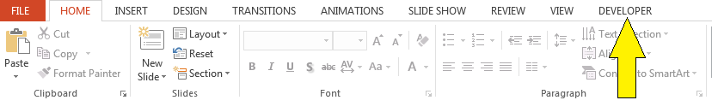

#### 2.2 If not enable the Developer plugin

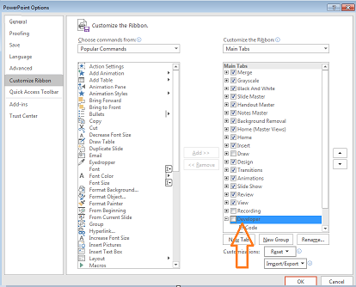

### MS Outlook Plug-in (for emailing)

Go to ***Tools*** -> ***References*** -> Find and select *“****Microsoft Outlook 16.0 Object Library****”*

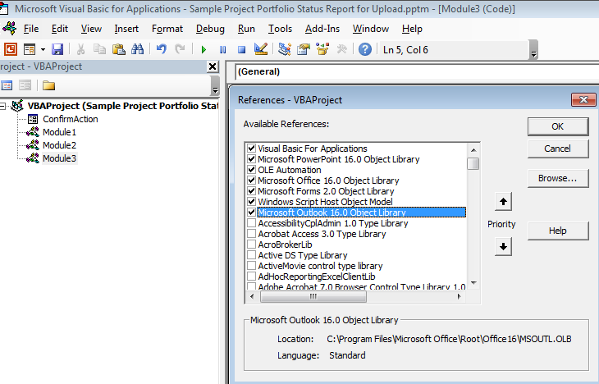

### WebDAV

WebDAV, similar to FTP, is a HTTP extension (essentially a protocol) from Microsoft that enables managing documents over the web, including publishing to Web (sites), and applicable for use over SSL as well (unlike FTP), as well as capable of using directory service authentication system such as LDAP or Microsoft Active Directory. We will be using WebDAV to map a SharePoint site (encrypted over SSL, as the most typical SharePoint implementation is) to a network drive to programmatically upload reports (*older version of Windows might run into issues with mapping drives using WebDAV, refer to troubleshooting reference below for details*).

I am skipping taking a deep dive into WebDAV and comparisons to other file transfer protocols viz. FTP, SSH, SFTP ( I haven’t explored in details, beyond the point that WebDAV is best suited and most convenient for the automation purposes here), but more details for reference provided below:

[http://www.webdav.org/](http://www.webdav.org/other/faq.html#Q1) (also check the FAQs if you are new to it)

Click below on how to install and configure WebDAV (Server set up)

<https://www.iis.net/learn/install/installing-publishing-technologies/installing-and-configuring-webdav-on-iis>

***Ensure WebDAV client is enabled and running***

On your computer, go to Control Panel -> Administrative Tools -> Services.   
Scroll down to select WebClient, as below: 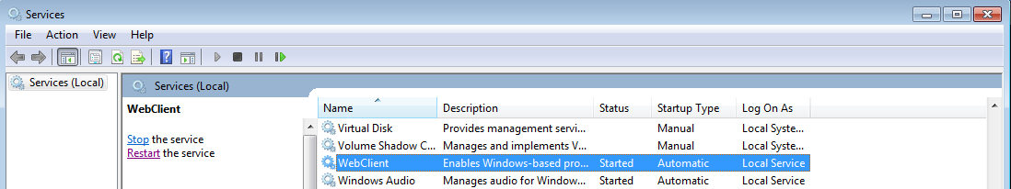

Set WebClient to automatic and start the service. You might have to restart Windows if it fails.

## **The automation process**

The macro below, at a high level, execute the following, as shown below:

1. Create a copy of the PowerPoint (.pptx), in a temporary location to (to prevent any changes to master file).
2. Spit out each project status file as a .pptx.
3. Save each file as .pdf (or any other format)
4. Upload .pdf to respective project SharePoint (or shared location)
5. Email the status report (.pdf) (or link to the status report) to respective stakeholders
6. Repeat for each of the projects in the portfolio/program

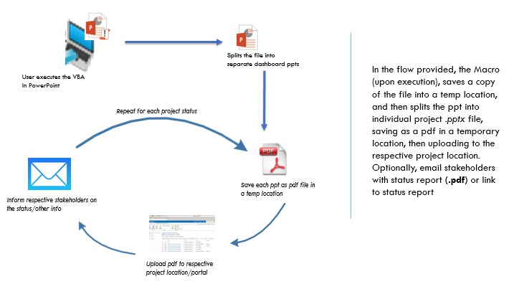

### **The code**

Below I will show a simple use case to upload files to respective SharePoint portals:

1. Upload the entire portfolio as pdf (composed of each project dashboard in one page, including separate pages for title and summary of all projects
2. Upload individual file to respective project portals.

Below is a sample portfolio report (consisting of two projects for simplicity) with a title page, a high-level summary page, and dashboard page each for the two projects whose status is being reported.

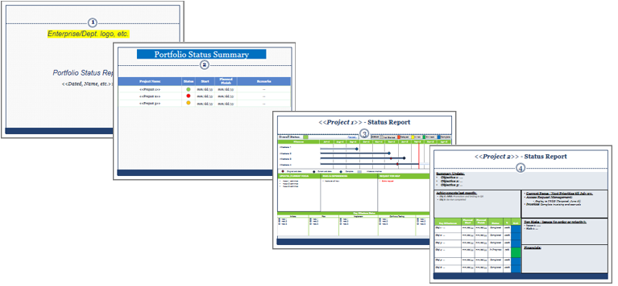

#### 2.2.4 **The code**

I have kept the code as simple as possible, not adding any error Handlers either to make it clear to understand

I have created separate modules for subroutine to make is easy to follow here, use your discretion as to how to want to compartmentalize the subroutines and modules:

Components (Modules and subroutines)

##### A ***user form*** (to capture user input or preferences – if required)

###### What is does:

As mentioned in the sample above, I capture the user input to decide if I need to publish the summary portfolio report for my (department) Leadership only or publish each project dashboard for other departments stakeholders as well.

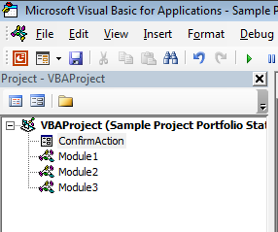

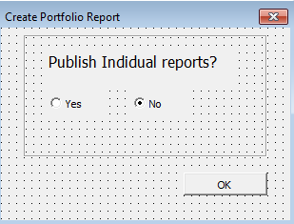 

##### Module 1: ***Singles*** Subroutine

###### What is does:

1. Creates a temporary folder in a pre-defined temp local folder and saves a copy of the PowerPoint format (.pptx)
2. Optionally, create a list to blacklist which project statuses will not be uploaded to respective SharePoint portals
3. Spit out each project status file as a .pptx.
4. Save each file as .pdf (or any other format)

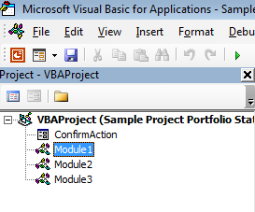 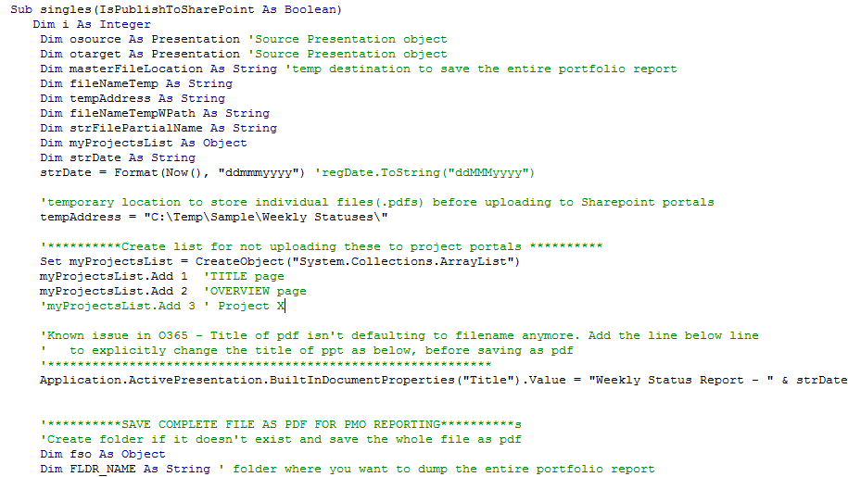

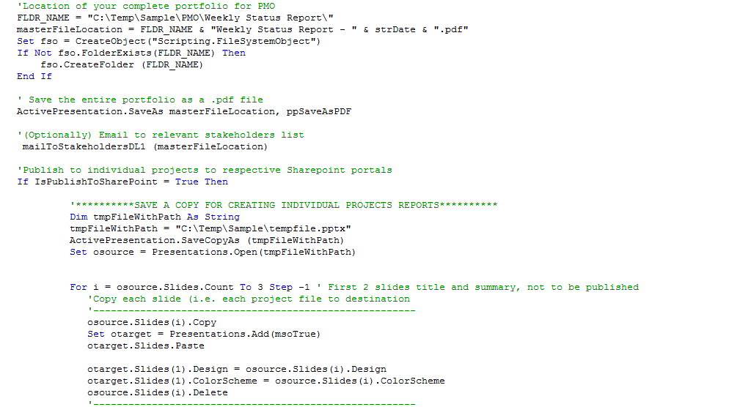

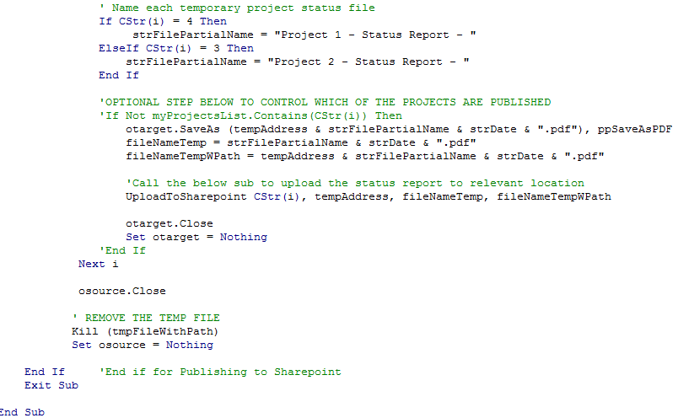

##### Module 3: ***Email*** Subroutine

###### What is does:

Emails the status report as .pdf to email receivers. Alternately, email a link to the newly uploaded file, and add and format the body text as necessary.

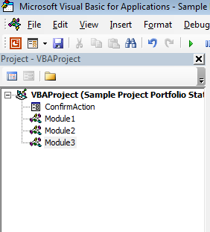 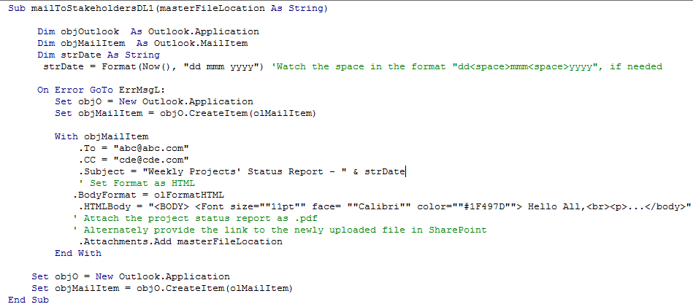

##### Module 2: ***Upload to SharePoint*** Subroutine

###### What is does:

Upload the pdf to respective SharePoint portal. Optionally, archive (here simply moving to an Archive folder) the older files already present in the SharePoint location.

Please note below how one is accessing a (SharePoint site) as a drive with WebDAV.

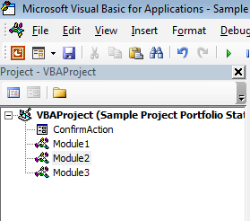

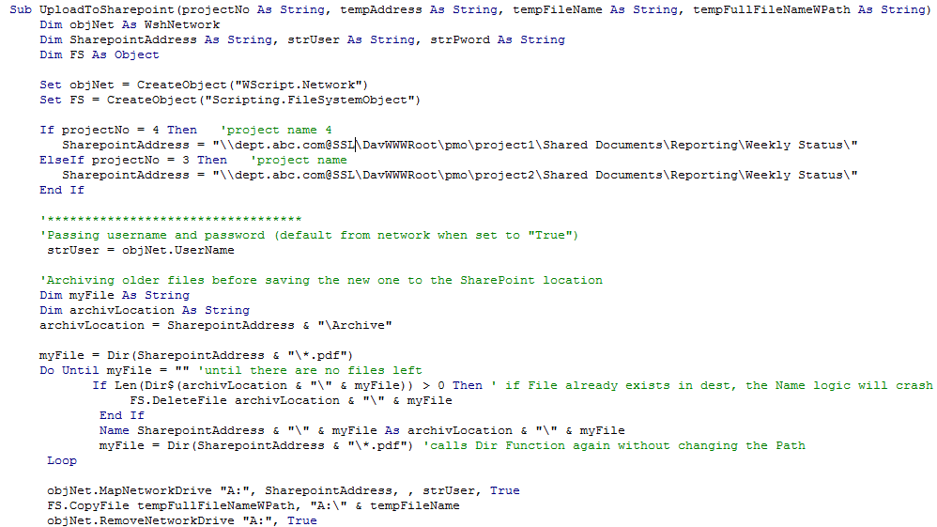



### **Key issues & troubleshooting tips:**

The key known issues are mentioned below:

#### 1.3.1 Unable to map drive to WebDAV site:

##### **Root cause 1**: WebClient not started

***Resolution***: Make sure WebClient is running locally (see above how to restart WebClient)

##### ***Root cause 2***: Web share on the IIS server was set for Basic Authentication only, can lead to MapNetworkDrive can run into issues connecting

***Resolution:*** Add Windows Integrated Authentication to the web share (if you have admin privileges or someone else can do it for you).

If not, either re-start the computer or manually connect to the WebDAV drive by copying the path and pasting on to Windows explorer, as below.

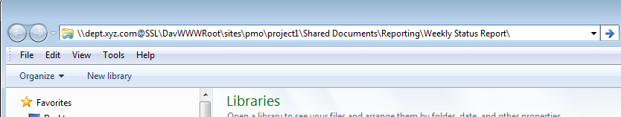

It will ask to manually add username/password below, once done should be good to go

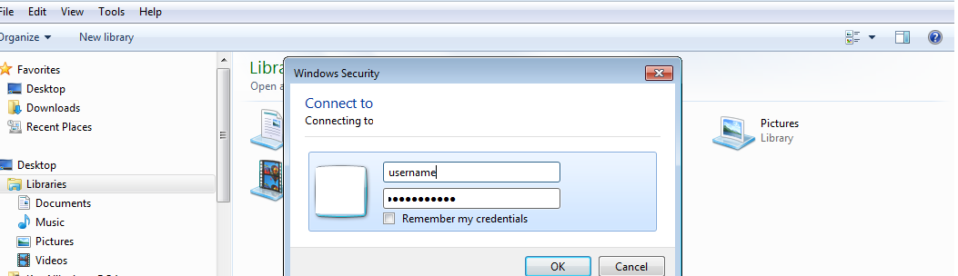

*If this is an issue, and you want to put some error handling to prevent further processing (including sending emails out) if WebDAV folder is not accessible due to authenticate needs, and put a check for authentication success at the start of VBA code, and exit the sub with a warning (to rectify using one of the options provided above) in case of failure.*

#### 1.3.2 Further Troubleshooting references

* [Installing and Configuring WebDAV on IIS](https://www.iis.net/learn/install/installing-publishing-technologies/installing-and-configuring-webdav-on-iis)
* Authentication with Office [documents](https://support.microsoft.com/en-us/help/2019105/authentication-requests-when-you-open-office-documents)
* [Map Network Drive / WebDAV with SharePoint Online O365](https://blogs.technet.microsoft.com/sharepoint_made_easy/2013/03/20/map-network-drive-webdav-with-sharepoint-online-o365/)

### **Variations to consider/Adapt to your needs**

You can easily tweak the VBA code (or rather the concept) to adapt to a variety of needs, below I am providing some of the most common uses I have adapted for below:

1. **Share a Summary Report only:** Share a high-level summary-only of entire portfolio for Leadership
2. **Share a master portfolio dashboard report**
3. **Archive older files before uploading the latest, for each of the projects/programs:** Eases the burden of cleaning up repositories periodically
4. **Various project repositories (Shared drive, SharePoint (with or w/o SSL) :** Customize the code to treat each upload differently, based on type (with a flag or number denoting the type) (e.g. Shared drive location, SharePoint (with or w/o SSL), etc.)

**About the Author**

Nil is MS in Computer Science and a PMP professional, having been working in the IT field for several years. His experience includes leading applications development, and managing applications, infrastructure and IT security projects and portfolios. He can be contacted at [nilanjan.kar@gmail.com](mailto:nilanjan.kar@gmail.com)

**References**

i *Authentication requests when you open Office documents.* (2017). Retrieved Mar 30, 2017, from https://support.microsoft.com/en-us/help/2019105/authentication-requests-when-you-open-office-documents

ii Robert McMurray, Microsoft. (2017). *Install and configure WebDAV on IIS.* Retrieved Mar 30, 2017, from https://www.iis.net/learn/install/installing-publishing-technologies/installing-and-configuring-webdav-on-iis

iii Jim Whitehead. (2010). *WebDAV Resources.* Retrieved Mar 30, 2017, from http://www.webdav.org/

iv Msdn.microsoft.com. (2017). *Object model (PowerPoint VBA reference).* Retrieved Mar 30, 2017, from https://msdn.microsoft.com/en-us/library/office/ff743835.aspx?f=255&MSPPError=-2147217396

v Blogs.technet.microsoft.com. (2017). *Map Network Drive / WebDav with SharePoint Online O365*. Retrieved Mar 30, 2017, from https://msdn.microsoft.com/en-us/library/office/ff743835.aspx?f=255&MSPPError=-2147217396